UNCOVERING THE GAMING INDUSTRY’S HIDDEN GEMS:A COMPREHENSIVE ANALYSIS of VIDEO GAMES SALES

1.Overview:

Video game sales analysis is the process of collecting and analyzing data about the sales of video  
games in order to understand market trends and consumer behavior. This type of analysis can be  
useful for a variety of purposes, including identifying the most popular games and genres, predicting  
future sales, and developing marketing strategies.Video game sales analysis typically involves  
collecting data from Kaggle sources. It was generated by a scrape of vgchartz.com. This data may  
include information about the number of units sold, the retail price, and the platforms on which the  
games are played. Once the data has been collected, it is typically analyzed using tableau. The  
results of the analysis can be used to identify trends and patterns in the market, and to make informed  
decisions about the development and marketing of video games.Video game sales analysis may be  
conducted by game developers, publishers, retailers, and other industry professionals. It is an  
important part of the video game industry, as it helps to understand the needs and preferences of  
consumers and to identify opportunities for growth and innovation.  
Analysing sales data from more than 16,500 games. This dataset contains a list of video games with  
sales greater than 100,000 copies.It was generated by a scrape of vgchartz.com

2.1.Empathy Map:



2.2.BRAINSTORMING MAP:



3.OUTPUT:

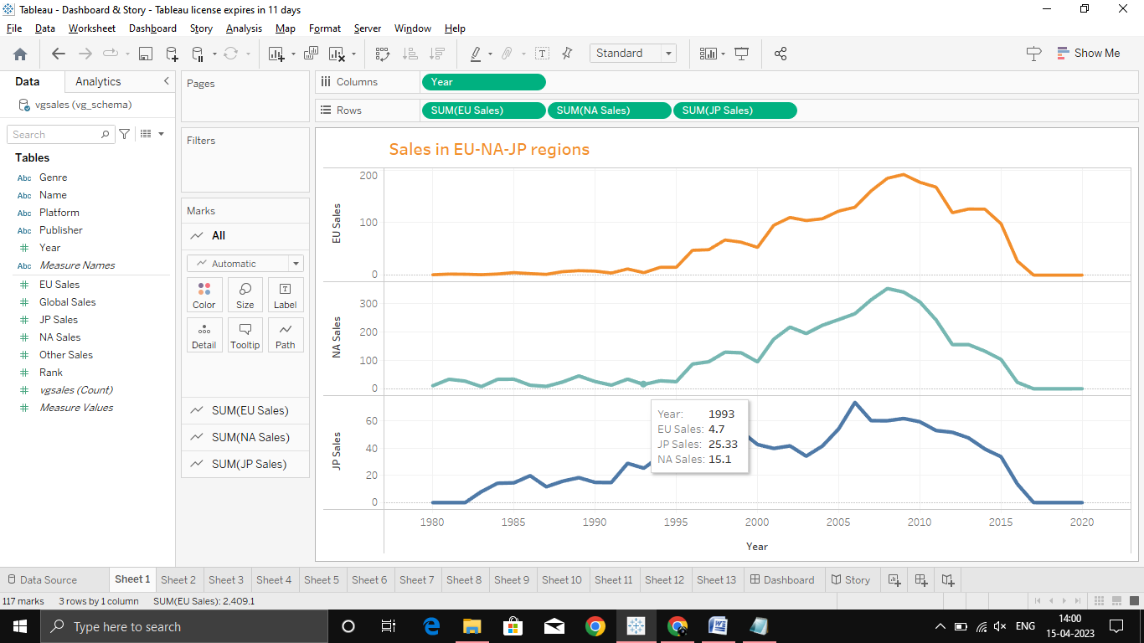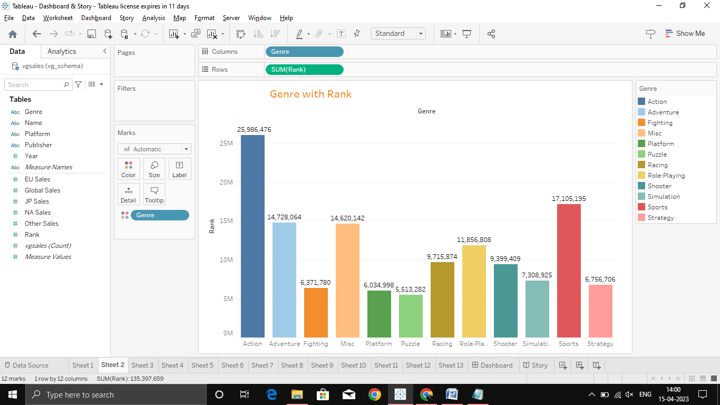

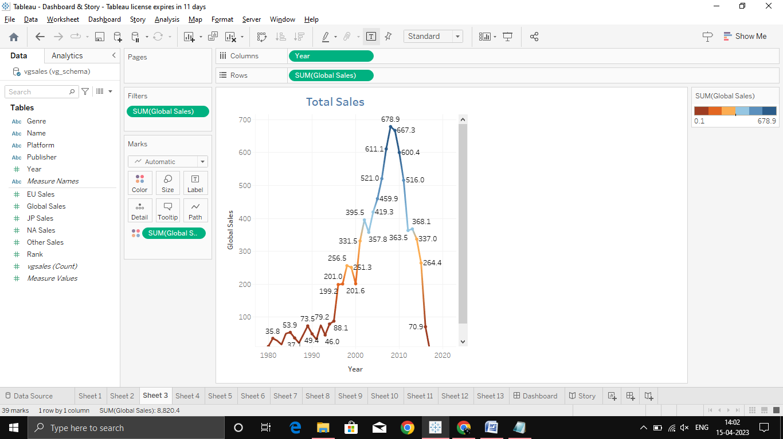



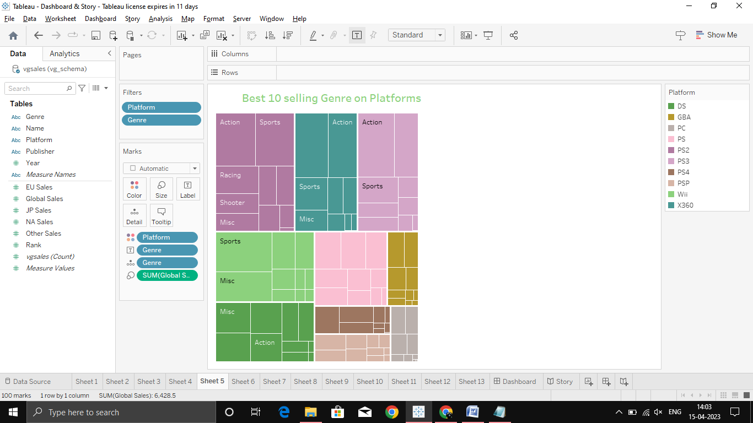







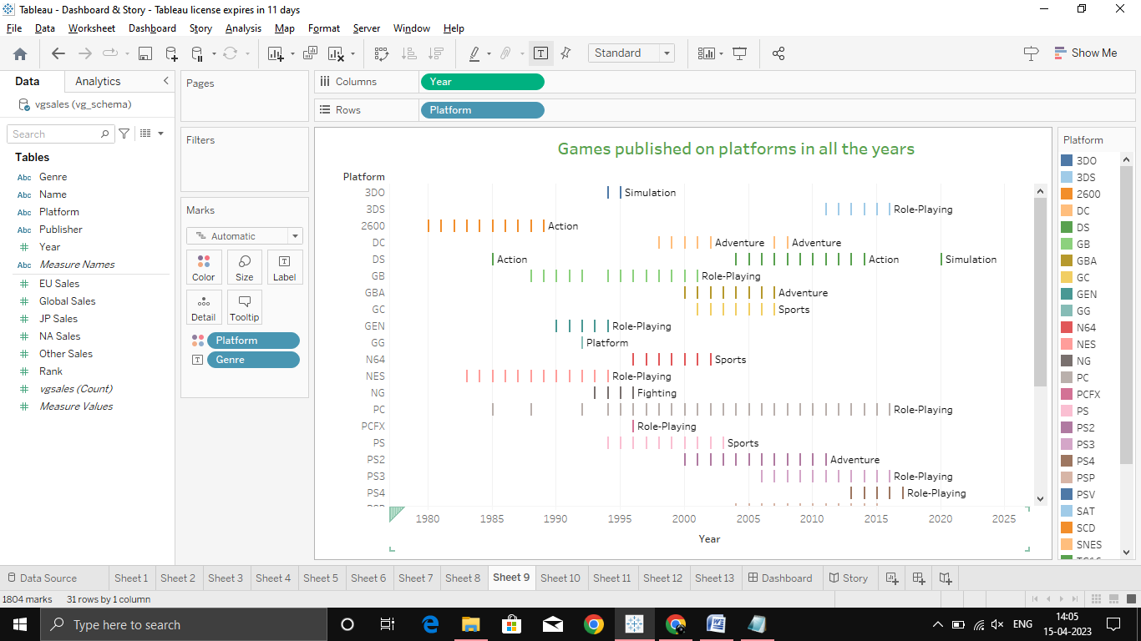

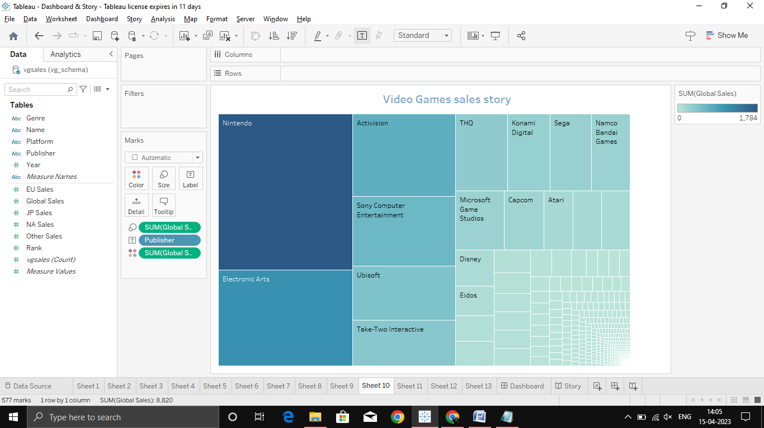





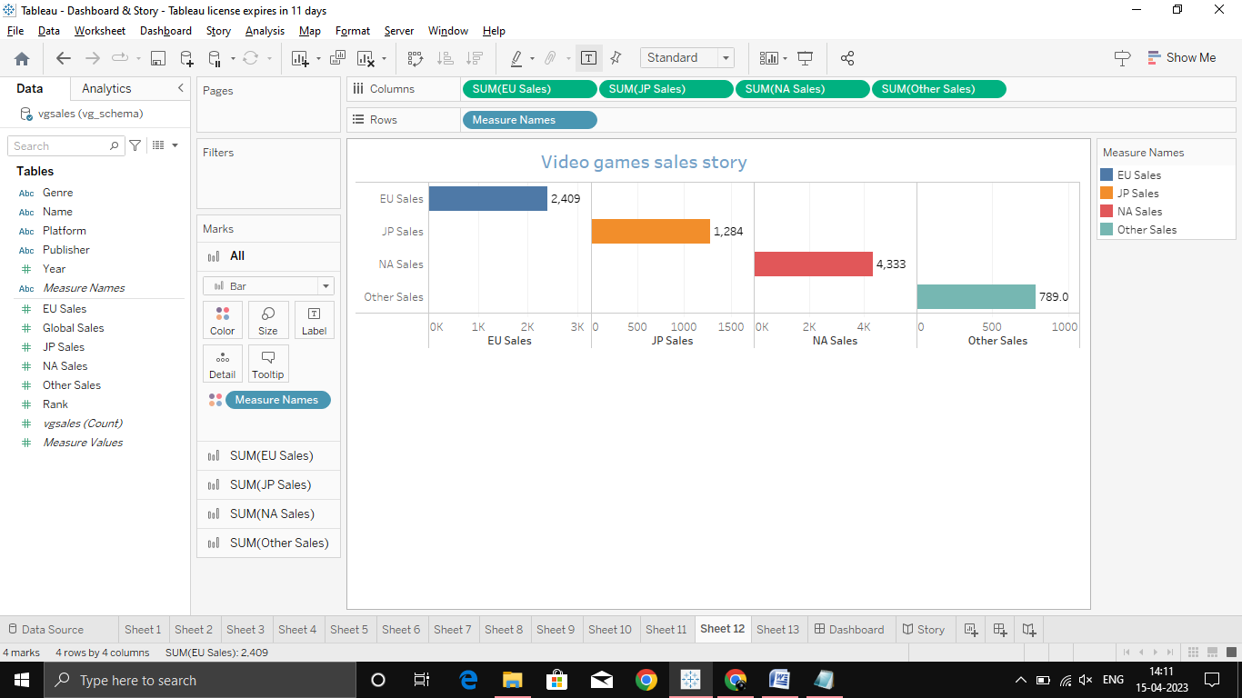

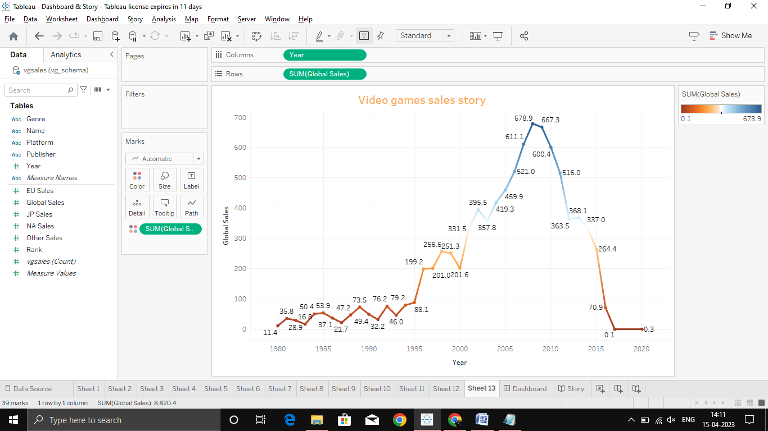



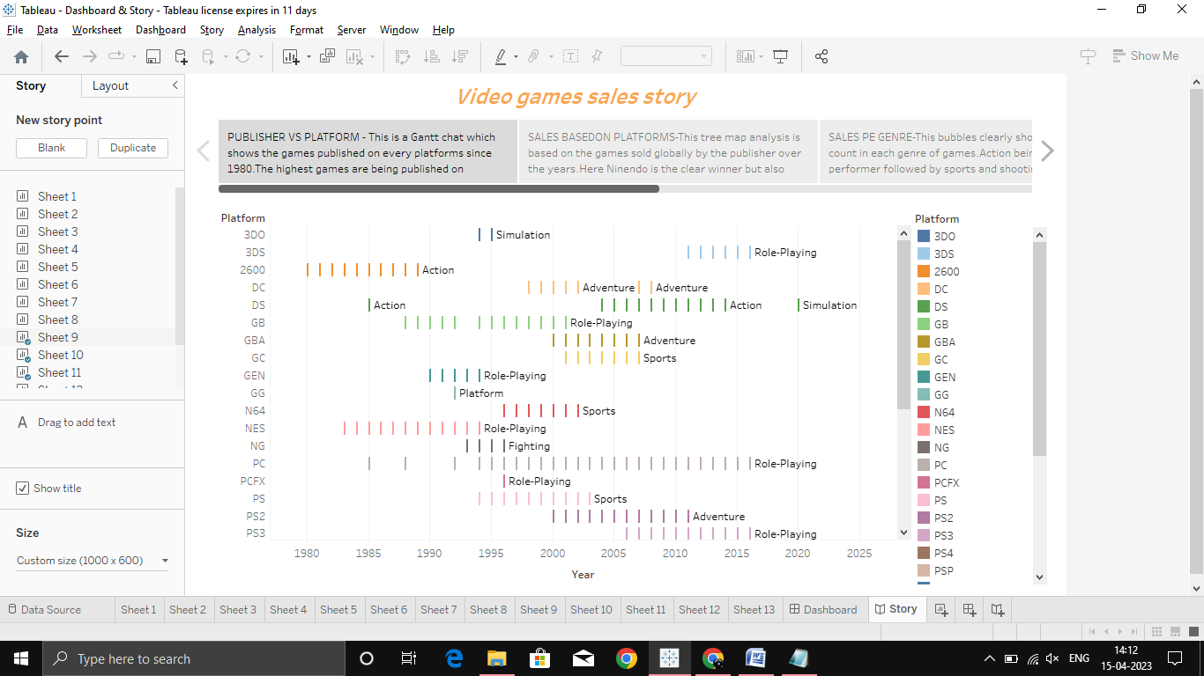

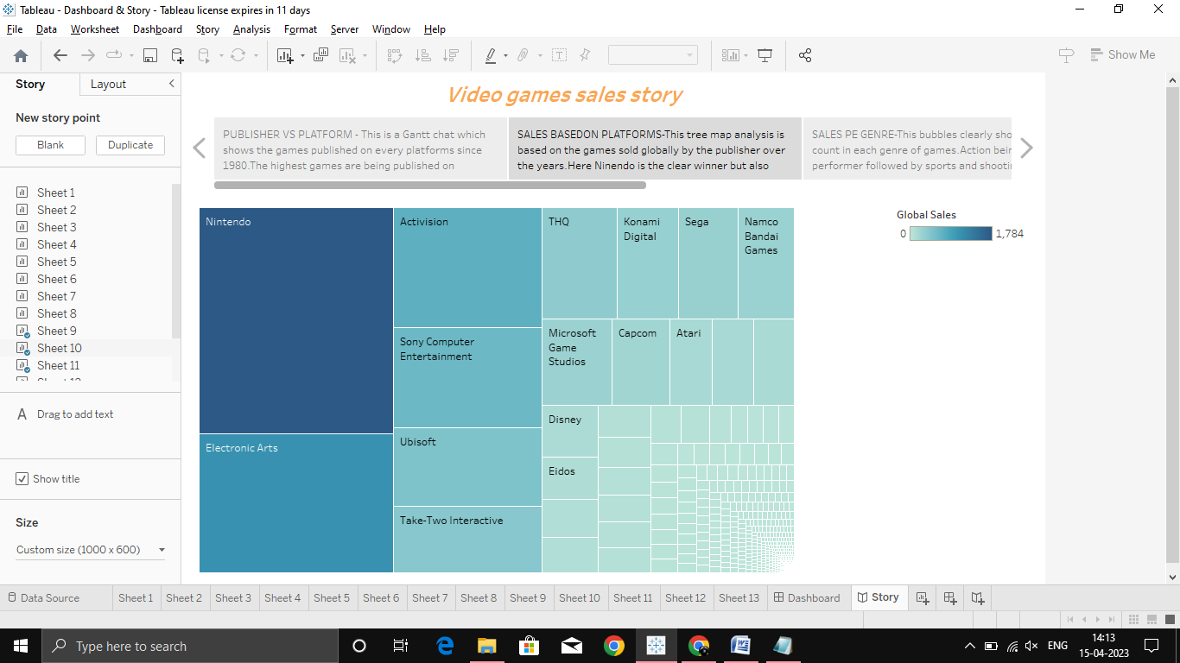



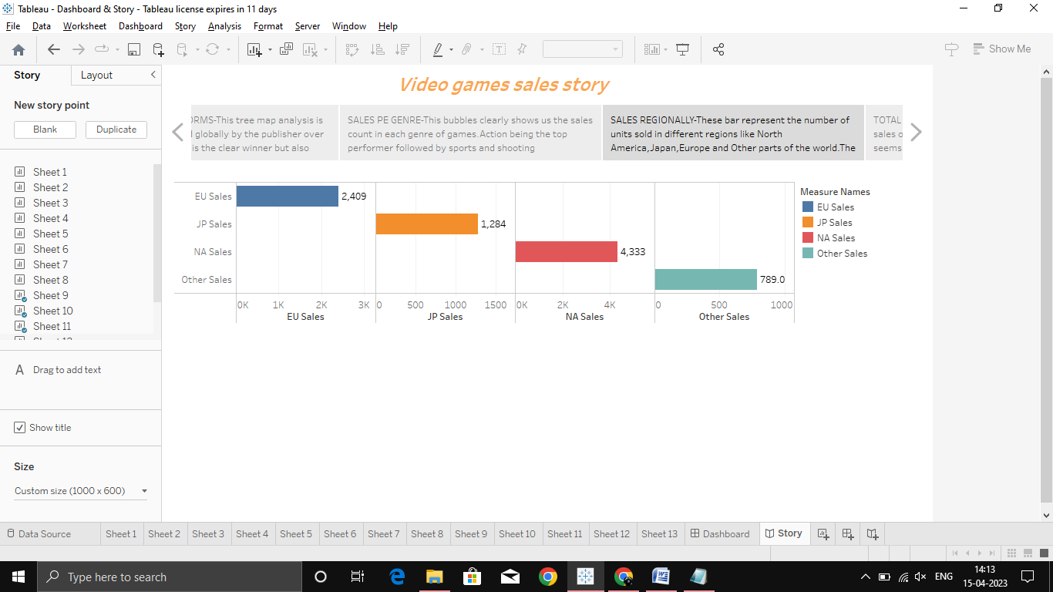

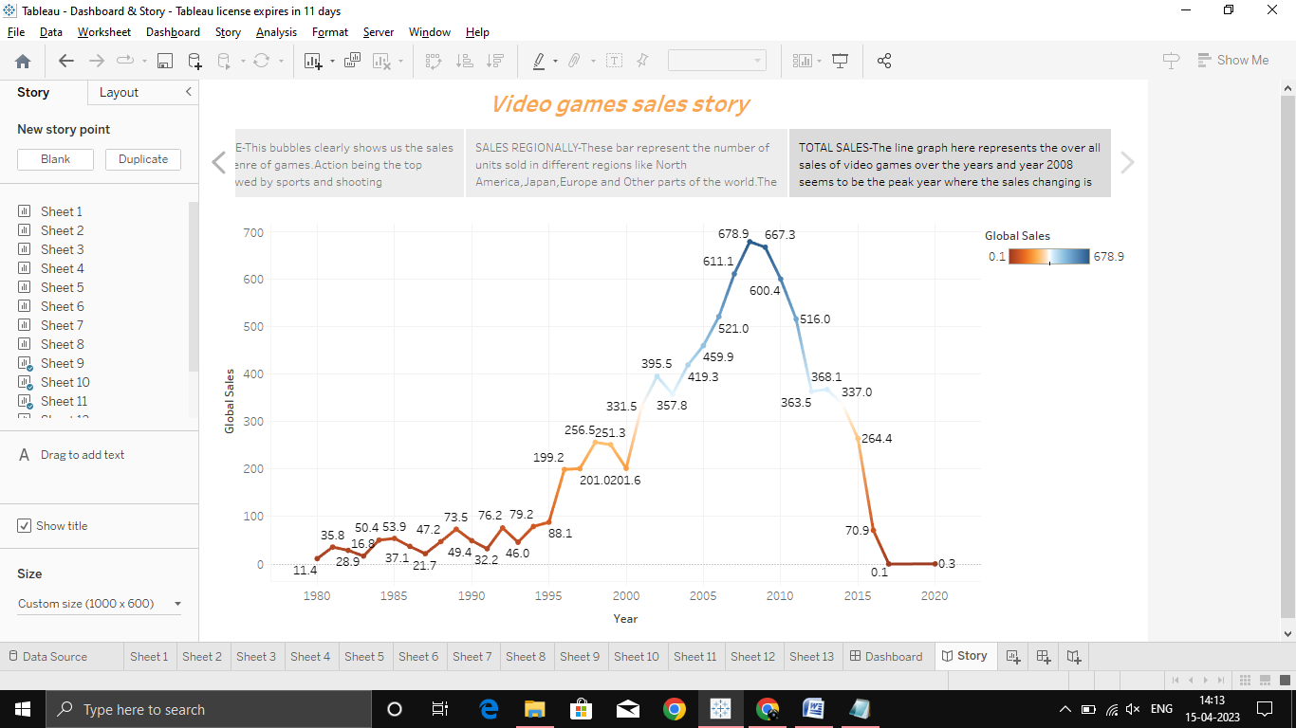

4.Advantange and Disadvantage:

Advantages of video games:

\*Enhances cognitive skills: Video games can help improve cognitive skills such as problem-solving, spatial awareness,

and decision-making.

\*Improves hand-eye coordination: Playing video games can help improve hand-eye coordination, which can be beneficial

in activities such as sports and driving.

\*Can be educational: Video games can be used to teach skills such as reading, math, and science.

\*Provides stress relief: Video games can be a great way to unwind and relieve stress.

\*Builds social skills: Multiplayer video games can help build social skills and promote teamwork.

Disadvantages of video games:

\*Can be addictive: Video games can be addictive, which can lead to excessive gaming and neglect of other important activities

such as work, school, and relationships.

\*Can be violent: Some video games contain violent content, which can be harmful to some players.

\*Can lead to sedentary lifestyle: Playing video games for long periods of time can lead to a sedentary lifestyle, which can

contribute to health problems such as obesity and heart disease.

\*Can be expensive: Video games and gaming systems can be expensive, which can be a barrier for some players.

\*Can lead to online harassment: Online multiplayer games can lead to online harassment and cyberbullying,

which can be harmful to some players.

5.APPLICATIONS:

Video games have a wide range of applications in various fields, including:

#Entertainment: The most obvious application of video games is entertainment. They can provide hours of fun and enjoyment

for players of all ages.

#Education: Video games can be used to teach various subjects and skills, such as history, science, math, and problem-solving.

Educational games can be especially helpful for children who may not be engaged with traditional learning methods.

#Training and simulation: Video games can be used to simulate real-life scenarios and provide training for professionals in various

fields, such as military, aviation, and medicine. For example, flight simulators can provide pilots with realistic training in a safe environment.

#Rehabilitation: Video games can be used in physical and occupational therapy to help patients recover from injuries or illnesses.

They can provide a fun and engaging way to improve mobility, coordination, and cognitive abilities.

#Mental health: Video games can be used in mental health therapy to help patients manage symptoms of anxiety, depression, and other disorders.

Games can provide a distraction from negative thoughts and help patients build coping skills.

#Advertising and marketing: Video games can be used as a platform for advertising and marketing products and services. Brands can create games

that incorporate their products or services and use them to engage with customers and increase brand awareness.

Overall, video games have a wide range of applications and can be used for entertainment, education, training, rehabilitation,

mental health,and advertising.

6.FUTURE SCOPE:

The future of video games is exciting, with advancements in technology and increasing demand from players. Here are some of the potential future

scopes for video games:

\*Virtual reality and augmented reality: Virtual reality and augmented reality technologies are expected to revolutionize the gaming industry.

These technologies will provide players with an immersive gaming experience, allowing them to interact with the game environment in a more realistic way.

\*Cloud gaming: Cloud gaming is an emerging technology that allows players to stream games over the internet without the need for a high-end

gaming PC or console. This technology will make gaming more accessible to a wider audience, and eliminate the need for expensive hardware.

\*Artificial intelligence: Advances in artificial intelligence will enable game developers to create more sophisticated and realistic

non-player characters (NPCs), which will enhance the gameplay experience.

\*Blockchain and cryptocurrency: Blockchain and cryptocurrency technologies are expected to play a significant role in the gaming industry.

These technologies will provide players with more control over their in-game assets and enable new forms of monetization for game developers.

\*eSports: eSports is a rapidly growing industry, with increasing interest from players and spectators alike. In the future, eSports is

expected to become more mainstream, with larger audiences, bigger prize pools, and more professional players.

Overall, the future of video games is bright, with exciting advancements in technology and increasing demand from players.

We can expect to see new and innovative games, as well as new ways to play and monetize games in the coming years.

7.CONCLUSION:

#In conclusion, the video game industry has come a long way since the early days of arcade games and consoles. Today, video games are a

major form of entertainment and a significant part of the global economy. The industry has seen tremendous growth in recent years, with advancements

in technology and increasing demand from players.

The industry has a wide range of applications, including entertainment, education, training, rehabilitation, mental health, and advertising.

In the future, we can expect to see even more innovative and immersive gaming experiences, with advancements in virtual and augmented reality,

cloud gaming, artificial intelligence, blockchain and cryptocurrency, and eSports.